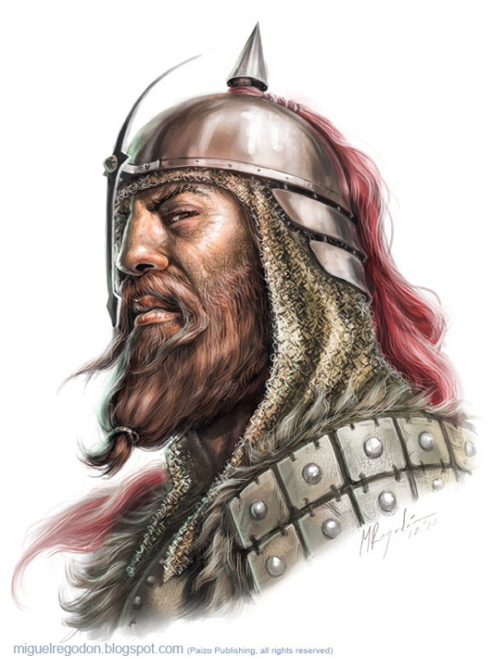
Bengeirr Haldyrson

-Ulfen male in his 30s
-son of Haldyr
-enemy of Skelg the Ripper
-follower of Gorum
-imposing, Scornful, Proud

The Longaxes are household mercenaries employed by Taldan royalty. Predominantly of Ulfen stock, these guards don’t understand the Taldane language and could care less about politics. This makes them well-paid (loyal) and discrete (oblivious).

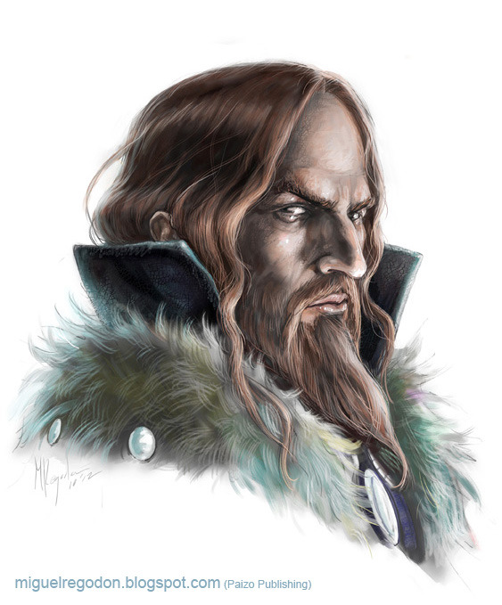
Skelg the Ripper

-Ulfen male in his 40s
-renown as a raider
-fellow Pathfinder
-employed as a Longaxe
-currently freezing to death
from some kind of curse
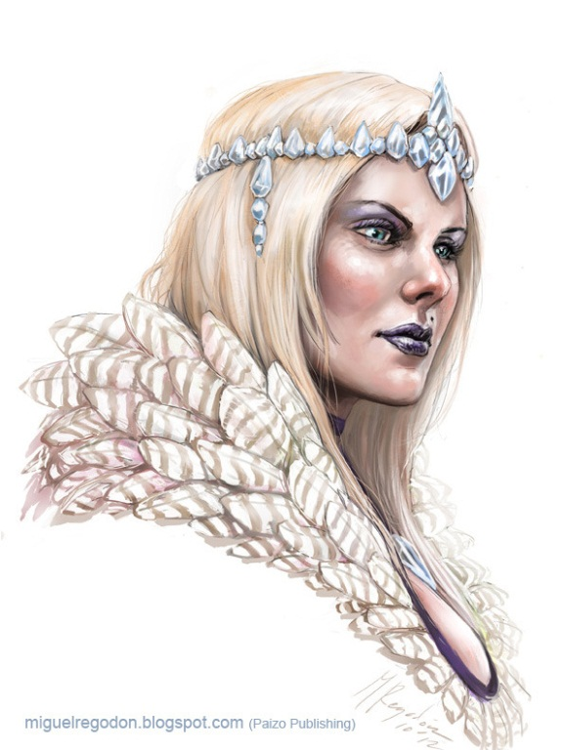
Natalya Bjornson
(née Yagevna)

-Ulfen female in her late 20s
-widow (3rd wife) of Haldyr
Bjornson
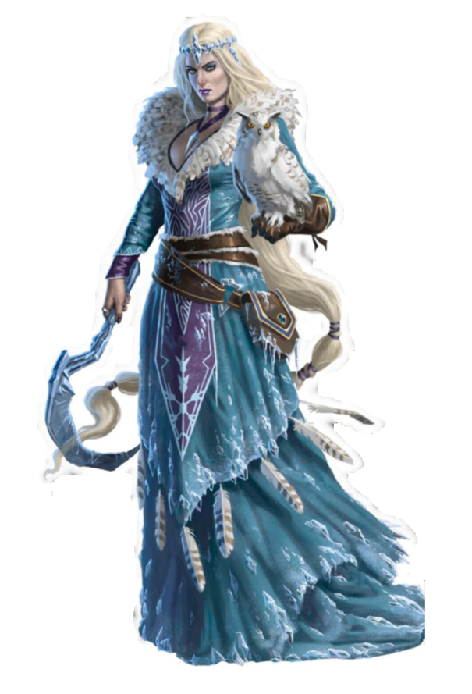
-native of Irrisen
-aristocratic, cold

The Beacon of the North is a huge bullseye lantern made from cold iron. It was crafted by the witches of Irrisen. It is designed to be hung from the prow of a ship and illuminate the course ahead. It weighs about 50 lbs.

