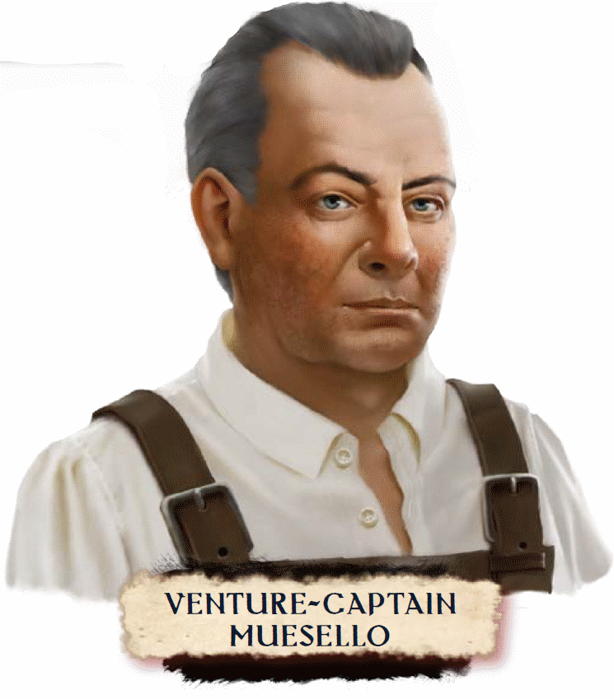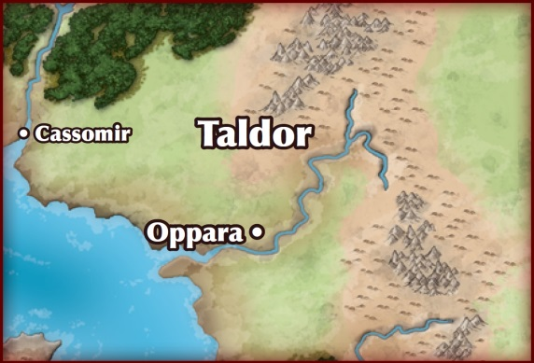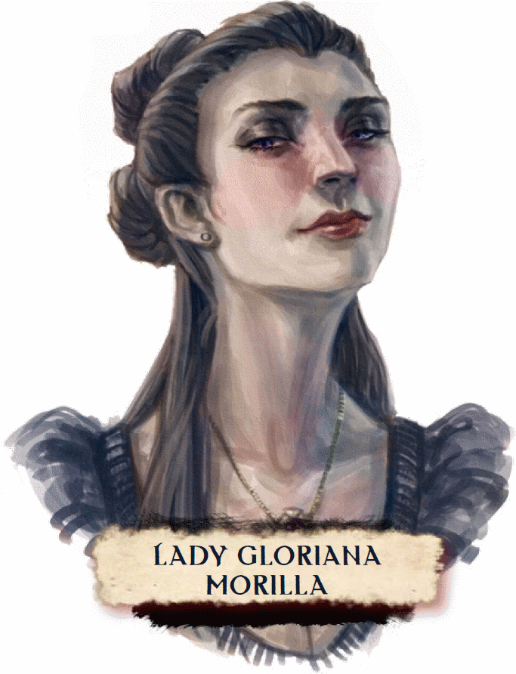

VC: Muesello:

The Pathfinder Society does not have a sterling reputation in Taldor, despite my and others’ efforts to impress the local movers and shakers. As a result, the most prestigious universities and colleges often deny our agents access to the best libraries in Oppara, thinking we are meddling good-for-nothings. As one of the oldest intact civilizations near the Inner Sea, these libraries no doubt house some very precious volumes. Recently we received a most wonderful opportunity—an invitation, really, from a very powerful patron,

This patron will secure us a couple hours in the rare books collection at the Kitharodian Academy, during which we may peruse for whatever we wish so long as we also retrieve several documents of interest for our friend. That is where things get interesting. Apparently there is an even more precious archive hidden beneath the academy’s library, and our patron believes it to contain numerous original records and undoctored historical accounts otherwise unknown to the world! Our contact knows how to get into the archive and has shared the secret with us.

Two hours is little time, so you must make the most of your time. I know it will be tempting to research other interests, but it would be selfish for the Society to think of itself when the Worldwound’s borders threaten to envelop Mendev and beyond. I am sending you in with the express purpose of uncovering more information about the Shining Crusade, the sustained war against the Whispering Tyrant a millennium ago.

Lady Morilla:

Historically, Taldor is the authority on massive military campaigns, but most texts have undergone extensive revision to serve some political agenda or another. Entering this hidden archive is an excellent opportunity to learn from the real mistakes of the past and apply those lessons to the Mendevian Crusade.

Remember that you have permission to be in the academy’s library, but not in this secret archive, so do everything you can to avoid being noticed while exploring. In fact, the fewer clues you leave of your passage, the better. Specifically do not steal or destroy any of the library’s contents. A few slip-ups might alert the authorities that someone has been poking around, and too many will give them enough evidence to trace this act to us.

Scroll/Letters:
The scroll tube contains an unsigned letter that describes many of the mission’s details from Princess Eutropia’s perspective as well as a formal request signed by the Arch-Exarch Gregorius to admit the bearers to the Kitharodian Academy’s rare books collection. The princess’s letter also explains that the Pathfinders can find the hidden entrance to the archive by studying honor, courage, and glory.

