A Gunslinger just sat down at my table. What do I need to know?

Ask the player three questions about their firearm(s):
- What's your range increment?
- What's your misfire range?
- How fast can you reload?
  - Optional 4th question: How big is your Grit pool?
  - Optional 5th question: Do you have Craft (Alchemy)? (see Ammunition below)

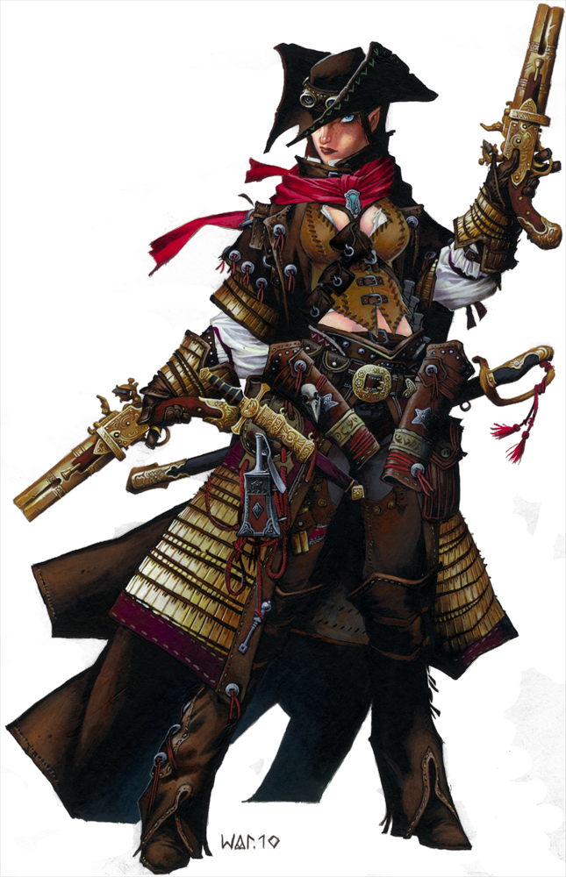
Firearms Basics
PFS only allows Early Firearms, specifically the following:
Buckler Gun, Coat Pistol, Dagger Pistol, Double-barreled Pistol, Dragon Pistol, Pepperbox, Pistol, Axe Musket, Blunderbuss, Double-barreled Musket, Fire Lance, Musket, Warhammer Musket
(available starting weapons in bold)
Firearms are not on the always available list of purchases.

Range Increments and Touch AC
Firearms target Touch AC when attacking within the weapon's first range increment.
Outside of the first range increment, the firearm targets normal AC, taking any penalties from extra range increments (maximum 5).

Misfires
Firearms have a misfire value. If the die roll falls within this range, the weapon gains the broken condition.
Using Alchemical Paper Cartridges will increase the Misfire Range for a firearm by 1.
More on Misfires (H/T Quendishir):
When a firearm misfires, several things happen:
First, your weapon gains the “broken” condition. While it has this condition, the weapon has the following:
- The weapon has a -2 penalty to attack rolls and damage.
- The weapon can only crit on a natural 20 and crits for double the damage, regardless of natural crit multiplier.
The weapon’s misfire value also increases by 4 (so if it only misfired on a natural 1, it now misfires on a roll of 1 to 5). If you have the Gun Training ability granted by the Gunslinger class, the value increases by 2 instead of 4.
When the weapon misfires, the attack is treated as having missed completely as normal.
Should the weapon misfire again, the weapon explodes. When this happens, you choose a corner of the square you inhabit. The weapon emits a gout of flame as it misfires, dealing damage equal to its normal damage to everyone in the weapon’s burst radius, including the wielder. A DC 12 Reflex save halves the damage. The burst size is noted in parentheses after the misfire value on the tables found in books. A weapon that explodes is unusable until it is fixed by either a Make Whole spell, or by using your Gunsmithing feat to repair it.
Common Misfire ranges:
- Pistol: 1 (1 - 2 using alchemical paper cartridges)
- Musket: 1 - 2 (1 - 3 using alchemical paper cartridges)
- Double-barreled Pistol: 1 - 2 (1 - 3 using alchemical paper cartridges)
- Double-barreled Musket: 1 - 3 (1 - 4 using alchemical paper cartridges)

Quick Clear
Gunslingers with the Quick Clear Deed (can be removed by Archetypes) can remove the broken condition as a Standard action provided they have at least one point in their Grit pool. They can also spend a point to clear as a Move action.
There are other methods of clearing a misfire, but they fall outside the scope of this guide.
GM Tip: If a Gunslinger misses a shot, ask them if it was a misfire (players usually remember on a 1, but may not on a 2 or 3 on the die)

Ammunition
A normal shot from a gun will cost 11gp (10gp for Black Powder and 1gp for a bullet).
Gunslingers with one rank in Craft (Alchemy) can reduce this to 1gp,1sp.
A normal Alchemical Paper Cartridge will cost 12gp (6gp with Craft(Alchemy)).

For more ammunition prices, please see the Appendix at the end of this document
GM Tip: Ask a Gunslinger how many bullets they have at the start of the game. This will help them remember to track expended rounds and purchase more at the beginning if needed.

Reloading
Reloading provokes AoOs.
Reloading requires a free hand.
You cannot normally load an early firearm underwater or fire any firearm underwater.
Common Reload times:
- One-handed Firearms: Standard Action (Move Action with Rapid Reload or Paper Cartridges, Free Action with Rapid Reload and Paper Cartridges)
- Two-handed Firearms: Full-Round Action (Standard Action with Rapid Reload or Paper Cartridges, Move Action with Rapid Reload and Paper Cartridges)
- Special: The Musket Master archetype allows a 3rd-level Gunslinger to treat a musket as a one-handed firearm as long as they have one point of grit)
GM Tip: Ask a Gunslinger if they have a free hand when reloading. A Gunslinger with two Pistols can use weapon cords to drop one to reload the other, but recovery of the dropped weapon is a Move Action (one per round).
GM Tip: Reloading each barrel of a gun is a separate action. For example, reloading both barrels of a Double-barreled Musket with Alchemical Paper Cartridges would take two Move actions, with each action provoking an AoO (assuming the Gunslinger has Rapid Reload: Double-barreled Musket).

Grit
Grit is a limited resource, like a Monk's Ki or Magus' Arcane Pool. Gunslingers will spend Grit points to perform Deeds, such as quick-clearing their weapon (effectively repairing it after a misfire) or adding damage. The mechanics of the various Deeds are outside the scope of this guide.
Gunslingers can regain a point of Grit when
- When you confirm a critical hit, you are refunded 1 Grit;
- When you reduce the hit points of a creature to 0 or less, you are refunded 1 Grit if their total hit dice are at least equal to half your character level;
- When you perform a dangerous act (“Daring Deed”), your GM can refund you 1 Grit. This is not authorized for Pathfinder Society Organized Play. (H/T Quendishir)
GM Tip: When a player spends a Grit point, ask them if it is their last point, as that may have an effect on one or more of her Deeds.

Appendix I: How much damage!?
Gunslingers can deal a surprising amount of damage. This is largely due to the fact that most of their attacks can be expected to hit, regardless of the enemy’s AC. This is mostly mitigated by the need to reload and by the higher risk of misfire when making a large number of attacks.

Common sources of damage for a Gunslinger include, but are not limited to:
- Point Blank Shot (all attacks): +1 damage (within 30 ft of target)
- Deadly Aim* (all attacks): +2 damage (+4 at BAB 4, +6 at BAB 6, +8 at BAB 12, with attack penalties similar to Power Attack)
- Gun Training (all attacks): +DEX modifier to damage (starting at 5th level for most Gunslingers)
- Pistol Training (Pistolero Archetype): +DEX modifier to damage (starting at 5th level)
  - GM Tip: As of 1/22/2014, the Pistolero’s Pistol Training has been updated to replace Gun Training. Players unaware of this change may be adding their DEX modifier to damage twice--once for each ability.
- Vital Strike (standard action only): Roll die damage twice (Standard Attack only)
- Dead Shot (full attack only): Roll multiple attacks for one shot as if it were a Full Attack, rolling damage dice for each hit and then adding any damage modifiers (costs 1 grit point, available at level 7 for most Gunslingers

*Note that the normal exclusion against ranged touch attacks for Deadly Aim is specifically excepted for firearms

Appendix II: Ammunition Prices
(H/T Nefreet):
Name of Ammunition | Regular Cost | Gunsmithing Cost
Black Powder (dose) | 10gp | 1gp
Black Powder (keg) | 1000gp | 100gp
Regular Bullet | 1gp | 1sp
Cold Iron Bullet | 2gp | 2sp
Silver Bullet | 25gp | 2gp, 5sp
Pitted Bullet | 5gp | 5sp
Adamantine Bullet | 61gp | 6gp, 1sp
Elysian Bronze Bullet | 21gp | 2gp, 1sp
Alchemical Silver Bullet | 3gp | 3sp
30 Mithral Bullets | 280gp | 28gp
10 Ghost Salted Bullets | 210gp | 21gp
Regular Paper Cartridge | 12gp | 6gp
Cold Iron Paper Cartridge | 24gp | 12gp
Adamantine Paper Cartridge | 72gp | 36gp
Elysian Bronze Paper Cartridge | 32gp | 16gp
Alchemical Silver Cartridge | 14gp | 7gp
Mithral Paper Cartridge | 262gp | 131gp*
Dragon's Breath Cartridge | 40gp | 20gp
Entangling Shot Cartridge | 40gp | 20gp
Flare Shot Cartridge | 10gp | 5gp
Salt Shot Cartridge | 12gp | 6gp
* mithral melee weapons with no listed weight are assumed to be 1/2 pound when calculating their cost, but no such rule technically exists for ammunition. For PFS we should probably assume they don't exist.

