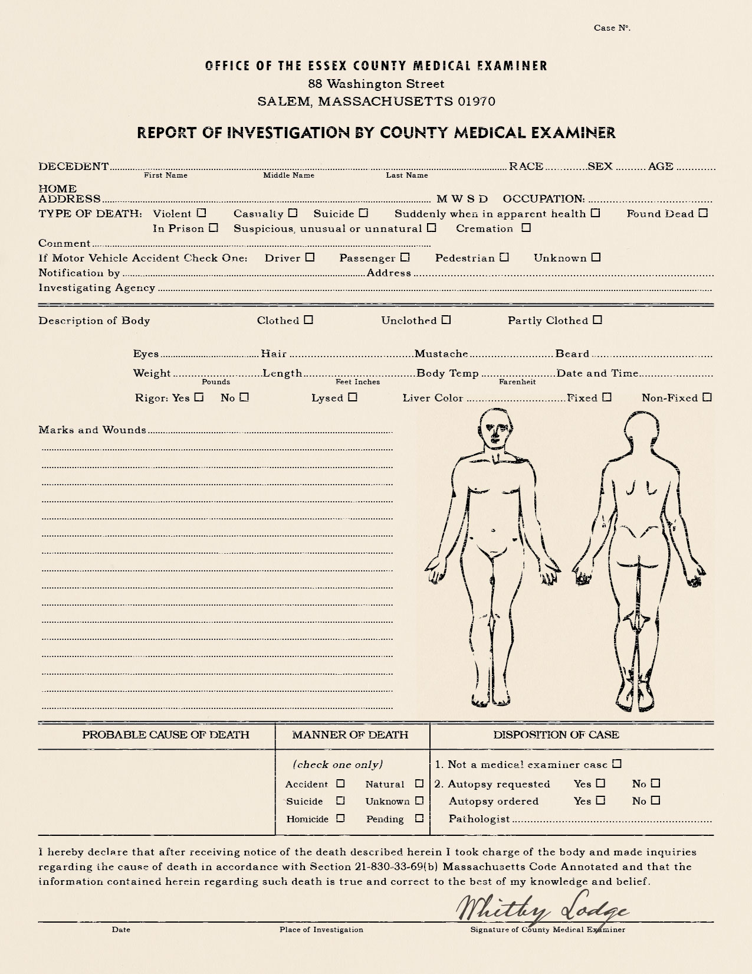
X
X
X
X
X
X
X
5-9 Slipper District
Act of God(s)?
The body has been twisted twice around at the waist like a knotted rag and whose arms are broken in so many places that they flop like tentacles. His chain shirt and sword are twisted like the rest of his body—whatever did this to the man was huge and incredibly strong
240 5’9” 98.0 3 pm
Brown Black Yes Yes
Carrion Hill City Guards/ Volunteers
One of three found- all with similar wounds
89 North Carriage Street City Guard
Margus Austiv Hemmerburg Human M 27 27
Carrion Hill City Guard
Slipper Market District

