

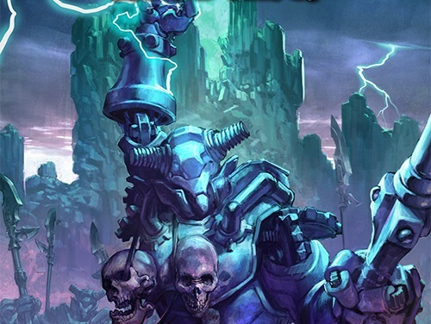

Emerald Spire



PFS Player's Guide

Emerald Spire

PFS safe Player's Guide

Written by: “Jester” David Gibson  (of the 5 Minute Workday webcomic & blog). Updated by “VarunCreed” Jeroen to be safe to use for Pathfinder Society Campaign. | Emerald Spire Superdungeon by: Keith Baker, Richard Baker, Wolfgang Baur, Jason Bulmahn, Ed Greenwood, Tim Hitchcock, James Jacobs, Nicolas Logue, Frank Mentzer, Erik Mona, Chris Pramas, Sean K Reynolds, F. Wesley Schneider, Michael A. Stackpole, Lisa Stevens, and James L. Sutter
Edited by awesome people like: Tyler Beck, “The Sword Emperor”, “Ashram”, rthormin, and a whole zoo of anonymous animals.  Original can be found here. | Thornkeep By: Richard Baker, Jason Bulmahn, Ryan S. Dancey, Ed Greenwood, Lee Hammock, James Jacobs, Mark Kalmes, Erik Mona, Lisa Stevens, and Michael Wallin

Legal
This document uses trademarks and/or copyrights owned by Paizo Inc., which are used under Paizo's Community Use Policy. We are expressly prohibited from charging you to use or access this content. This document is not published, endorsed, or specifically approved by Paizo Inc. For more information about Paizo's Community Use olicy, please visit paizo.com/communityuse. For more information about Paizo Inc. and Paizo products, please visit paizo.com.
This product makes use of the Pathfinder RPG Core Rulebook, Pathfinder RPG Advanced Player’s Guide, Pathfinder RPG GameMastery Guide, and the Character Traits Web Enhancement. These rules can be found online as part of the Pathfinder Roleplaying Game Reference Document at paizo.com/pathfinderRPG/prd.
This product is compliant with the Open Game License (OGL) and is suitable for use with the Pathfinder Roleplaying Game or the 3.5 edition of the world’s oldest fantasy roleplaying game.
Product Identity: The following items are hereby identified as Product Identity, as defined in the Open Game License version 1.0a, Section 1(e), and are not Open Content: All trademarks, registered trademarks, proper names (characters, deities, etc.), dialogue, plots, storylines, locations, characters, artwork, and trade dress. (Elements that have previously been designated as Open Game Content or are in the public domain are not included in this declaration.)

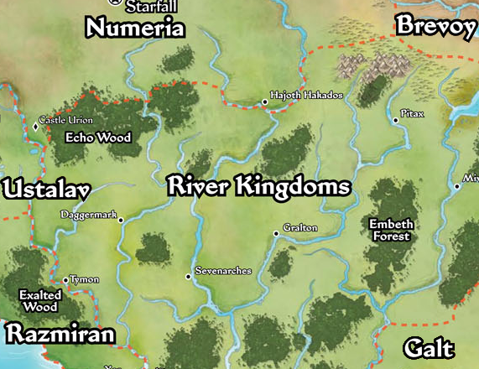
Region
The River Kingdoms are a collection of small kingdoms and city-states. The region lacks a central government and each realm is independently ruled.
The only laws recognized across the region are the Six River Freedoms:
- Say What You Will, I Live Free
- Oathbreakers Die
- Walk Any Road, Float Any River
- Courts Are for Kings
- Slavery Is an Abomination
- You Have What You Hold

In the northwest corner of the River Kingdoms lies the Echo Wood. The forest serves as the border between the River Kingdoms and Numeria and is separated from Ustalav by the West Sellen River, the Echo Wood is populated by independent settlements and homesteads living alongside barbarian tribes and goblins.
The Echo Wood is old, and filled with many ancient ruins. Most of these ruins belong to the fallen goblin empire of Zog, but some are far, far older. One such ruin is known as the Emerald Spire.

Emerald Spire Characters
A myriad of people and races can be found in the Echo Wood: the River Kingdoms are a melting pot attracting folk from all walks of life. Travellers and settlers come from neighbouring Numeria, Ustalav, and Razmiran, refugees flee from Galt or Brevoy, and crusaders heading to Mendev pass alongside the Echo Wood on their way to the Worldwound.
Below are some things to keep in mind when creating a character for Emerald Spire.
Cavernous Curiosity: Adventure lies below, in one dungeon or another. It is advantageous for characters to be motivated to continuously delve deeper and explore what lurks beneath.
Depths of the Earth: This adventure sends you deep underground, into forgotten dungeons and Darklands caverns. Classes and archetypes focused on exploration and dungeon delving will have an advantage. Characters primarily focused on social skills might be less suited to the adventure.
Exploring Ruins: The depths of the Emerald Spire hold many secrets from the ancient past, making Knowledge (history) and (dungeoneering) desirable skills. Traps and hazards might prove to be a danger, making Disable Device and Perception advantageous. Low-light vision or darkvision will also prove useful.
Tight Quarters: Large creatures are a liability in the cramped spaces, and creatures unable to fly or climb might have difficulty moving between levels in the dungeon. Classes with animal companions, especially mounts, might consider taking an archetype that replaces the animal companion.

The following are character background questions. Use these to help you flesh out your character and let your GM know.
- Are you (already) a Pathfinder? Why are you a Pathfinder? What Pathfinder Society faction are you from?
- Do you already know other Player Characters? Do you rely on for teamwork, survival and butt-kicking? Do you have a bro? a mentor? a father figure? maybe a rival?
- Why are you interested in investigating a dangerous dungeon that might kill you?
- Which nation did you grow up in? How did this nation influence you?
- Did you grow up in Fort Inevitable? If not, how did you end up there?
- What do you look like? What are your wearing? How does this vary when you’re stalking through forests, sewers, deserts or in glittering cities?
- What do you love? What do you hate?
- How does your race influence your views? Are you a stereotype of a certain race? How are you different from most humans/elves/gnomes/orcs/tengu?
- What are you afraid of? Do you have any phobias or worries?
- What is your most treasured possession?

Emerald Spire Campaign Traits

Character traits are used to customize a PC's background and tie her to the themes and events of an adventure. Each character begins play with two traits, one of which may be selected from the Emerald Spire campaign traits below. For general traits, see the Advanced Player's Guide or the Character Traits Web Enhancement, a free PDF download available at paizo.com. The traits below are safe to use for Pathfinder Society, if you own the source.
Additionally, most Pathfinder Player Companion supplements contain racial, regional, and faith traits unique to Golarion and suitable for use by Emerald Spire PCs.
Historian (Human): The fallen empire of ancient Azlant fires your curiosity and drives you to adventure. Tired of only learning of the empire through dusty tomes, you have followed rumours of Azlanti ruins to travel to the Echo Wood, hoping to unearth some new discovery. Perhaps you might even earn a mention of your own in a future historical tome.
You gain a +1 trait bonus on Knowledge (history) checks and bardic knowledge checks, and Knowledge (history) is always a class skill for you. [Source: Pathfinder Companion: Legacy of Fire Player’s Guide]
Scholar of the Great Beyond: Journeying along Crusader Road, hoping to join the Mendevian Crusade against the demons of the Worldwound, you found yourself tarrying at Fort Inevitable. At first it was merely a rest before continuing on your dangerous journey. However, rumours of strange phenomena around ancient ruins in the woods have caught your interest. Like the Hellknights of the Fort, you wonder if your skills might be more useful here than at the Worldwound.
You gain a +1 trait bonus on Knowledge (planes) and Knowledge (religion) checks, and Knowledge (planes) is a class skill for you. [Source: Pathfinder Roleplaying Game: Ultimate Campaign or (PFS) Pathfinder RPG Character Traits.pdf]
Fencer: The premier band of sellswords in Thornkeep, the Blue Basilisks are hired to guard caravans, escort travelers, and occasionally assault bandit hideouts. As a recent hire, you have been dispatched on the long and tiring task of accompanying a wagon of timber and goods from Thornkeep to Fort Inevitable. The journey began quietly, until halfway down Mosswater Road a band of goblins attacked, carrying off some of the cargo. The Blue Basilisks will be understanding, as goblins are a constant nuisance, but failing on your first assignment still feels shameful.
You gain a +1 trait bonus on attack of opportunity attack rolls made with daggers, swords, and similar bladed weapons. [Source: Pathfinder Roleplaying Game: Ultimate Campaign or (PFS) Pathfinder RPG Character Traits.pdf]
Underworld Explorer: For as long as you can remember, you have felt at home underground: the open spaces and endless sky of the above ground world unnerve you. You believe your destiny lies deep underground, and someday you hope to see the fantastic caverns of the Darklands beneath the surface or perhaps even visit one of the ancient vaults of Orv in the deepest layers of the Darklands.
You gain a +1 trait bonus on Knowledge (dungeoneering) checks, and a +1 trait bonus on Survival checks made in a specific area. One of these skills becomes class skill for you. [Source: Pathfinder Player Companion: Dragon Empires Primer]
Suspicious: You were raised in one of the many small villages or points of interest throughout the Echo Wood. You were raised on a farm or ranch, or perhaps a small hamlet nestled deep in the forest. To you, both Thornkeep and Fort Inevitable are "the big city," crowded places with too many people for comfort. You’ve been raised to be equally wary of bandits, monsters, and Hellknights: any who deny folks the Six River Freedoms.
You gain a +1 trait bonus on Sense Motive checks, and Sense Motive is always a class skill for you. [Source: Pathfinder Roleplaying Game: Ultimate Campaign or (PFS) Pathfinder RPG Character Traits.pdf]
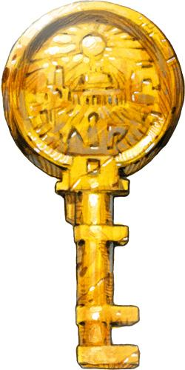
Freed Slave: To the Hellknight rulers of Fort Inevitable, freedom is a privilege to be earned: a privilege you lost. You spent the last few years as a slave, paying off accrued debts or as a punishment for crimes. At long last you have earned your freedom and can finally begin your life anew; friends and charitous figures have even offered to supply you with the coin and equipment to start over. Your time as a slave has left its mark. While the Hellknights prevent open abuse of slaves, few masters are kind and your enslavement has hardened you. You might have worked the fields for the fair, if heavy-handed, Naldred Tillman; at the tannery of the cruel Drurn; or staffed the bellows for the foul-tempered Tsador Ironmaker.
You gain a +1 trait bonus on all Fortitude saves. [Source: Pathfinder Companion: Legacy of Fire Player’s Guide]
Lover of the Law: You work as a servant or deacon at the Temple of the Golden Key in Fort Inevitable, the largest and most ornate temple in the Echo Wood region. You serve at the pleasure of High Mother Dremagne, priestess of Abadar. However, most of your time is spent following the wishes of the junior acolytes and lay priests. While you are mostly tasked with mundane jobs, your skills have not gone unnoticed and you have been increasingly entrusted with more and more important tasks for the temple.
Requirement: Abadar. You receive a +1 trait bonus on saving throws against charm and compulsion effects, and may attempt a new saving throw with an additional +1 bonus (for a total of +2) if you are directed to break the law. [Source: Pathfinder Campaign Setting: Inner Sea Gods]
Self-Taught Scholar: Thornkeep’s arcanist's guild primarily serves to protect the financial interests of its members, limiting competition and preventing price undercutting. As a low-ranking member of the Goldenfire Order, you are assigned the least pleasant tasks, but are thankfully well-paid for your services. Members are mostly left to their own interests, so you have learned little from the guild and are beginning to realize your education might be in your hands. Some extra action might also be required to stand out in the guild and find more profitable work.
You gain a +1 trait bonus on Linguistics checks to decipher unfamiliar languages, and Linguistics is always a class skill for you. In addition, you gain a +1 trait bonus on Spellcraft checks made to decipher the writing on a scroll. [Source: Pathfinder Roleplaying Game: Ultimate Campaign]
Armor Expert: The Hellknights of Fort Inevitable were crusaders who opted to end their pilgrimage and defend Crusader’s Road for the benefit of future crusaders. The Order's devotion to law and structure has long appealed to you and you have trained hard in the hopes of one day joining the order to protect Fort Inevitable and your kin from the endless bandits and roving beasts that prowl the land. You were initially mentored by the newly arrived Hellknight, Signifer DiViri, but she vanished some time ago while on an expedition, leaving you to continue your training on your own. Knowing that being able to ride quickly and move through the heavy underbrush of the woods is valuable, you have focused your training on the intimidating heavy armour of the Hellknights.
When you wear armor of any sort, reduce that suit's armor check penalty by 1, to a minimum check penalty of 0. [Source: Pathfinder Roleplaying Game: Ultimate Campaign or (PFS) Pathfinder RPG Character Traits.pdf]
Market Rat: You have strong ties with a merchant in either Thornkeep or Fort Inevitable, either through friendship or family. They’re willing to invest in your expeditions by spending some of their own coin purchasing treasure and are able to quickly order items you desire from elsewhere in the River Kingdoms. You’re a regular with Pick one of the following merchants:
Thom Braddon of Braddon's General Store in Fort Inevitable.
Mormuk Goldfoot of the Goldfoot’s Mercantile trading house in Fort Inevitable.
Yunar Barask of the Thornkeep Mercantile general store and trading post.
Requirement: Keleshite. You gain a +1 trait bonus on Appraise and Knowledge (local) checks. [Source: Pathfinder Player Companion: Humans of Golarion]
Bandit: The roads of the Echo Wood are commonly frequented by brigands, particularly along the seldom-patrolled roads leading to Thornkeep. The Hellknights have recently made it their task to stamp out banditry along Crusader’s Road, harshly punishing those outlaws they capture. You spent a number of years as a bandit, earning a living off travellers and traders. Having barely escaped justice on several occasions, you have decided it is time to retire from banditry, living a somewhat more honest life. But your meager savings will not last forever, so you will need to find some other means of employment.
Choose one of the following skills: Escape Artist, Intimidate, or Stealth. You gain a +1 trait bonus on that skill, and it is always a class skill for you. [Source: Pathfinder Player Companion: Inner Sea Primer]
Reluctant Apprentice: You have been trained in the arcane arts by Abernard Royst, the resident sage of Fort Inevitable. For the last several years your time was spent assisting the wizard with assorted research projects and experiments, long enough to see past Royst’s cantankerous exteriour to the caring master underneath. The aged sage seldom leaves the Fort any more, trusting you and his other apprentices to do his errands. As the most promising of his apprentices, the difficult tasks most often fall to you.
You gain a +1 trait bonus on Knowledge (arcana) checks, and are considered trained in that skill even if you have no ranks in it. [Source: Pathfinder Roleplaying Game: Ultimate Campaign]
Savage: Formerly of Numeria, the Wolfmane tribes sought a new homeland some centuries ago and have taken up residence in the Echo Wood. Dwelling in the forests around Thornkeep, the Wolfmane make their living as hunters, trappers, and scouts. You were raised in one of Kellid tribes and are comfortable in the wilds; few know the Echo Wood like the Wolfmane. But there are dangers in the woods, which might one day threaten your kin, and you feel obliged to defend your tribe.
You gain a +1 trait bonus on Knowledge (nature) checks and a +1 trait bonus on Survival checks to get along in the wild. Knowledge (nature) is always a class skill for you. [Source: Pathfinder Roleplaying Game: Ultimate Campaign]

The Echo Wood Area
The Echo Wood marks the northwest border of the River Kingdoms. It is a mixed temperate forest of various hardwoods thick with underbrush. The woods have a reputation for being difficult to navigate and even experienced woodsmen new to the Echo Woods find themselves easily lost.

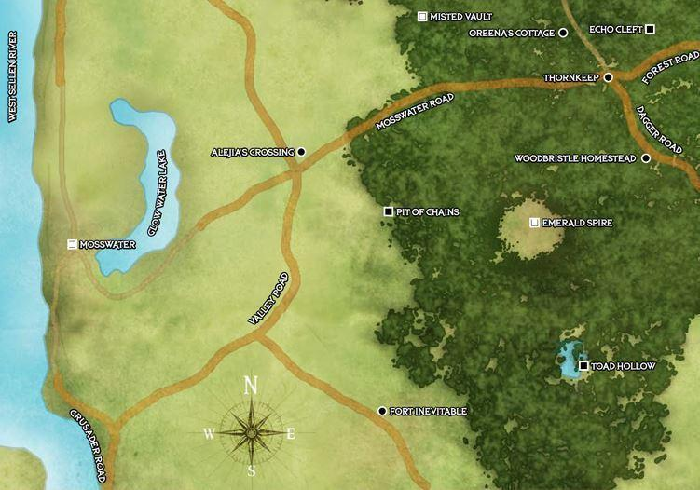

There are numerous small settlements and locales in the region.
Alejia’s Crossing: Set on the crossroads of Valley Road and Mosswater Road is a small inn run by a retired adventurer. The inn serves merchants and travellers alike, but the area is said to be frequented by bandits who prey on the unwary.
The Emerald Spire: This small keep of vibrant green crystal is ancient, possibly being one of the oldest structures in the region. The central spire of the keep is comprised of a strange green glass harder than granite. The clearing surrounding the Spire is curiously devoid of trees and the dense underbrush of the surrounding woods. It is common knowledge that beneath the ruins is a dungeon, but its size is unknown, as the ruin has never been fully explored.
Fort Inevitable: A bastion of law in a lawless region. Fort Inevitable is a small city mercilessly ruled by an order of Hellknights who have dedicated themselves to defending the town and Crusader’s Road from bandits, monsters, and other dangers. Fort Inevitable is one of the few locations in the River Kingdoms to permit slavery, and many crimes are punishable by a length of forced servitude. However, while the Hellknights permit slavery, they do not condone the abuse of slaves.
Most of the inhabitants are fine with their overlords, focusing their energy on farming and equipping the assorted crusaders heading north to the Worldwound. Those who can stay out of the way of the Hellknights are happy for the security they provide. However, not all residents are content with the Hellknights’ rule, and there are rumours of a resistance movement gaining in numbers.
Mosswater: Abandoned fifty years ago after a series of merrow attacks, the town is a reminder than the Echo Wood are not safe, even for larger settlements. The ogres that devastated the town still lurk in Glow Water Lake, encouraging travellers to detour around that stretch of Crusader’s Road for the safer Valley Road.
Oreena’s Cottage: Grandmotherly Oreena is a druid who works to spread the Green Faith, teaching the townsfolk of Thornkeep respect for the woods.
Thornkeep: A forest stronghold frequented by brigands, pirates, mercenaries, and barbarians. Thornkeep is ruled by the strong, who are able to take what they want and keep what they have. This lawless town harbors the dangerous and the desperate, and serves as a location for bandits to spend their tainted gold.
However, there are a number of honest folk who make their living in and around the town; while Thornkeep is dangerous, it is safer than the wilds of the Echo Woods. Artisans earn a decent living, providing a necessary service and needed goods, and there is a thriving logging industry providing lumber for the assorted homesteads and points of interest in the region.
Woodbristle Homestead: The home of a large halfling family who live secure behind their goblinbramble fortifications. The halflings are known for their extensive mushroom gardens.

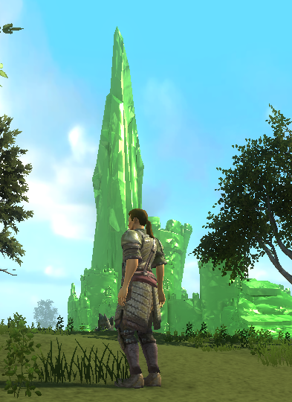
The Emerald Spire
Six miles northeast of Fort Inevitable lies one of the deepest and strangest dungeons to be found anywhere in the lands of the Inner Sea—the Emerald Spire. Like an iceberg, this weird structure shows only a small portion of itself above the surface; level upon level of hidden vaults and mysterious crypts lie buried deep below the ground. Few of the people living in Fort Inevitable or the surrounding lands have even the slightest inkling of the dungeon’s true extent, let alone its astounding age.
Standing in a wide clearing within the Echo Wood, the Emerald Spire is the ruin of a large Azlanti tower that appears to be made of green glass harder than stone. The upper portions of the tower were destroyed long ago, leaving broken, halfmelted glass blocks lying jumbled around the tower’s perimeter and the ground nearby. The site is well known to locals from both Fort Inevitable and Thornkeep, and many travelers passing through the Crusader Road area make the trek into the forest to look on the ruins—from a safe distance. The Spire’s ruins are known to be infested with dangerous monsters, and the surroundings attract an unhealthy number of bandits, raiders, and hungry predators.

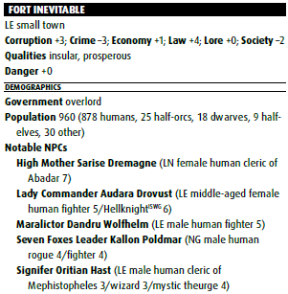
Fort Inevitable
Between the Echo Wood and the broad expanse of the West Sellen River stands a resolute stronghold of law and order: the walled town of Fort Inevitable. From its stern keep, companies of Hellknights ride forth to enforce the strict laws of their commander and bring authority to the unclaimed lands of the Crusader Road. While the taxes imposed by the town’s rulers are heavy and the laws inflexible, no one can deny that prosperity has followed the Hellknights’ establishment of hard justice in this small corner of the River Kingdoms. Merchants, travelers, and adventurers journeying on the Crusader Road find that Fort Inevitable provides a rare island of safety in an otherwise lawless land—so long as one is careful not to run afoul of the Hellknights’ laws.
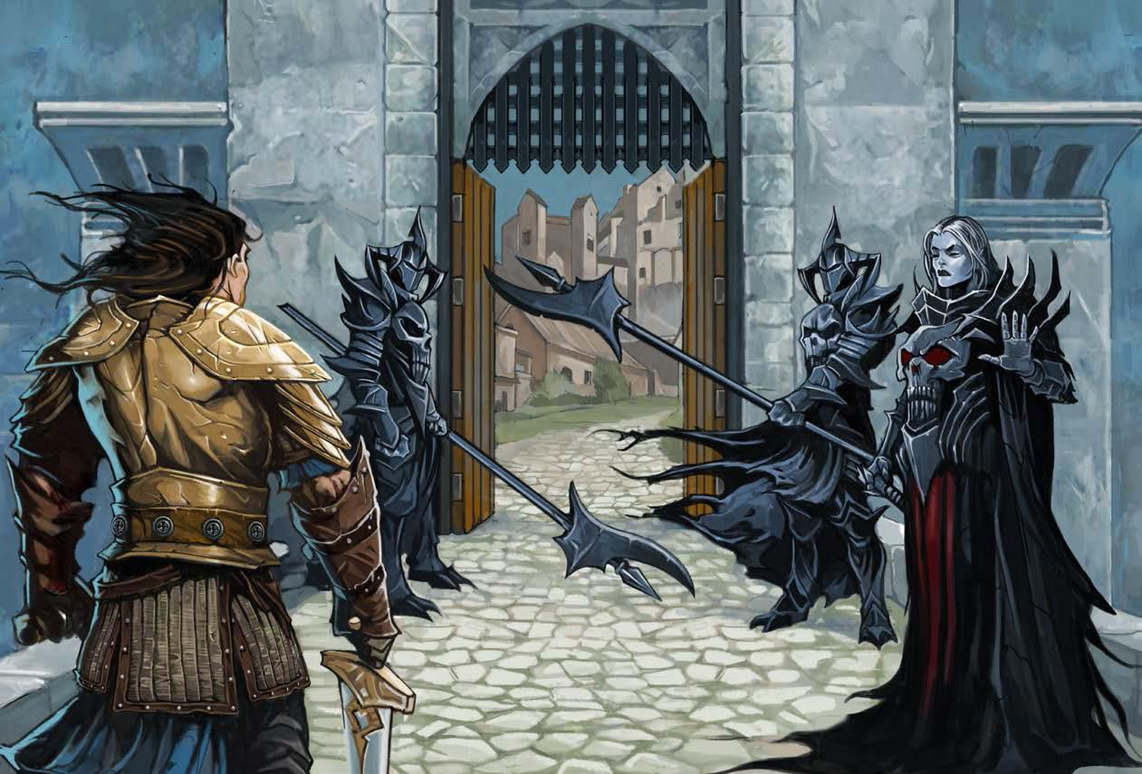

The current commander is a stern, middle-aged Chelish woman named Paralictor Audara Drovust. She is the commanding officer of the Order of the Pike’s chapter in the Crusader Road region, ruler of the Citadel, high magistrate, Fort Inevitable The Emerald Spire Superdungeon tax assessor, director of public works, keeper of the treasury, and chief regulator of business and commerce.

The Hellknights forcefully patrol Fort Inevitable and the surrounding lands, enforcing Drovust’s strict laws. They swiftly intervene to break up brawls and prevent crimes. They maintain a long “wanted” list of known or suspected criminals, and regularly circulate sketches or descriptions of suspects. Bandits and other criminals from nearby towns have a saying: “The Hellknights never forget.”

While obvious monsters are fair game to all, the Hellknights do not recognize the right of any self-declared adventurer to kill “villains” and seize their belongings. That’s common banditry, and those who ride back to Fort Inevitable after committing such vigilantism can expect to be arrested— unless they’ve first secured a letter of warrant.

A letter of warrant is a license from the lord commander authorizing the bearer and her company to “act in the interest of good order and keep the lady commander’s laws.” The lady commander’s agents also require reports of just what actions were taken with a letter of warrant.

While the lady commander seems to wield complete authority, appearances can be deceiving. Two other Hellknight orders—the Order of the Nail and the Order of the Gate—maintain presences on the Crusader Road, and while they defer to Drovust, each maintains its own chain of command and works toward its own purposes. Much of the town’s wealth is concentrated in the hands of the Council of Prosperity, a group of wealthy merchants and industry owners that exerts a good deal of influence over the Hellknights’ decisions. Finally, the lady commander is bound by her order’s vows and regulations; the Hellknights don’t break their own laws.

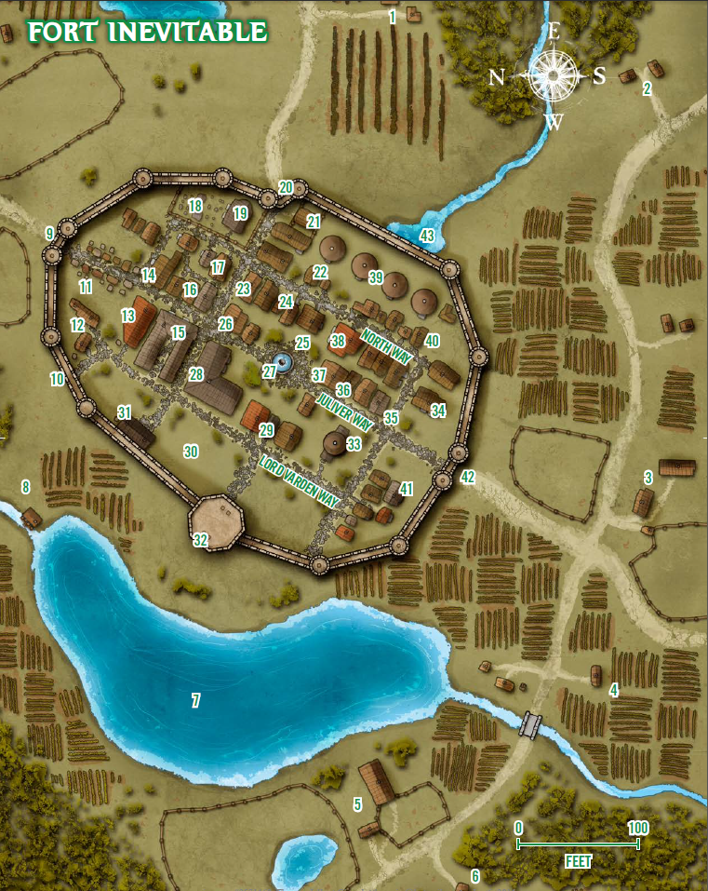
1: Caerlin's Vineyard (Farm) Home of old half-elven Caerlin and his daughter Taeserle.
2: Stonde Homestead (House) Home of the widow Ilyanda Stonde and her children. Her son Davon has been heard talking to other kids about the “goblin fort” he found in the forest.
3: Drurn's Tannery (Shop) Retired half-orc sellsword Drurn keeps a dozen slaves to work in the Tannery. He’s routinely in trouble with the Hellknights about his excessive treatment of the slaves.
4: Naldred's Farm (Farm) Naldred Tillman his farm are filled with expansive fields of golden wheat. As the largest private slave owner, he is a staunch supporter of the Hellknights’ rule.
5: Holworth Dairy (Farm) The green hillside overlooking Misty Lake is home to the Holworths, a large and rambunctious clan of native Southwooders who have lived in this spot for the better part of 2 centuries.
6: Serragon Ironworks (Foundry) The ironworks’ proprietor is Daldar Serragon, a former nobleman of Galt who fled to the River Kingdoms 20 years ago to escape the gallows. Daldar is not much of an artisan, but he has the loyalty of an excellent ironmaster, the dwarven smith Hurmarsk Firehammer.
7: Misty Lake Misty Lake is fed by both a small, unnamed stream that flows out of the southern Echo Wood and springs under the low hill on which Fort Inevitable stands. The lake is deep, reaching 50 feet in its middle.
8: Kettlefoot Mill (Farm) The well-established halfling miller Anden Kettlefoot is the owner of this large and prosperous mill. More than once he has stepped in to save an unfortunate citizen from going into debt and losing everything to the lady commander’s court—a dangerous habit that hasn’t won him many friends among the Hellknights.
9: Mosswater Gate (Gate) This gate consists of a large timber door sheathed in iron plate, plus a portcullis on the inner side. The Mosswater gate is under the command of Maralictor Kiera Wirt. She leads a detail of five Hellknighs who question everyone entering or leaving town.
10: City Wall (Wall) The walls average 30 feet in height and are a little more than 10 feet thick at the base.
11: Gate market (Shops) Local farmers and livestock-keepers apply to the Citadel for licenses to bring their produce, dairy goods, and meat to market on a regular rotation. “I heard it by the gate” is a local expression for the rumor mill.
12: Zoldor's Masonry The establishment of the stonemason and builder Zoldor Maril. He sorely resents the Hellknights’ heavy taxes and their insistence on fair dealing, but his work is safe and solid.
13: The Juliver Arms (Inn) Large and comfortable by anyone’s standards, the Juliver Arms is the best inn to be found in Fort Inevitable. It’s under the management of a bustling clan of halflings named the Reedbanks, who pride themselves on setting a lavish table. The accommodations are not cheap: the Reedbanks cater to wealthy merchants and adventurers with loose pockets.
14: The Red Shield Tavern Named for the striking coat of arms hanging in the common room, the Red Shield is a busy taphouse that is especially popular with the Hellknights.
15: Poldmar Stables This large livery store, carriage shop, and stable is under the management of Kallon Poldmar, a respected member of the Council of Prosperity.
16: Gertrand Yeldun (Home) A comfortable townhome on Juliver Way, this house belongs to the human moneychanger Gertrand Yeldun.
17: Mirelinda the Clothier (Shop) The flamboyant Varisian Mirelinda Doumaz owns this workshop and regularly hosts lavish entertainments at her home, and often scandalizes the town with her affairs. There are many dark rumors about where she found the coin she needed to establish herself in Fort Inevitable.
18: North Gate Cemetery The grounds of the Temple of Silence are well tended, and there have been no problems with undead in living memory.
19: Temple of Silence (Church of Pharasma) The Temple of Silence has stood here for almost 200 years, founded after a priestess of Pharasma passing through was struck by a powerful vision on this spot.
20: The North Gate Smaller and less busy than the gates on Juliver Way, the North Gate is intended for foot traffic only.
21: Garrison Stable The Hellknight in charge of the stable is Hielon Keenlance, a battered and scarred old veteran.
22: Nolm Bindery (Shop) Trading in papermaking, bookbinding, inks, and books of all kinds, Falandra Nolm’s Bindery is a cluttered and friendly place that is part workshop and part used bookstore.
23: The Stalwart Priory (Monks) A small number of monks from the Taldan Order of the Stalwart Fist answered the call of the Mendevian Crusade. Three years ago, a master of the order named Sister Khedra established a small priory in the Crusader Road region to aid and support pilgrims and Stalwart Fist members on their way to Mendev.
24: Serfurd's Potions and Reagents (Shop) Londor Sefurd is an unpleasant character with an oily, wheedling manner and an unhealthy interest in exotic toxins. He deals in potions, spell components, alchemical
25: Rillin's Armory (Shop) Master armorer Rillin Nadinghad is widely acknowledged as the best crafter of plate armor for a hundred miles around Fort Inevitable.
26: Braddon's General Store (Shop) Owned and operated by the affable merchant Thom Braddon, this shop sells provisions, tools, cookware, tack and harness, and a hundred other useful things.
27: Victory Fountain This fountain consists of a stone plinth within a pool, crowned by a statue of the half-elf heroine Tarwynna, leader of the army that crushed the goblin kingdom of Zog.
28: Hall of Rectitute (Courthouse) Cases of criminal and civil justice in Fort Inevitable are heard in this imposing courthouse. The Hall of Rectitude is home to a pair of spacious courtrooms, the offices of the town’s magistrates, and an extensive jail that’s usually quite full of prisoners, most serving short sentences for minor offenses.
29: Mardyl Barracks The original stronghold of Southwood is now used as an auxiliary barracks by the Hellknights. Lady Drovust assigned the Mardyl Barracks to the Order of the Nail, and allows them to use it as their local headquarters.
30: The Bailey (Training Grounds) This open ground in front of the Commander’s Citadel acquired it’s name years ago when the Hellknights were considering the construction of a much larger keep on this spot, and the name stuck. The wide, green field serves as the Hellknights’ primary practice ground inside Fort Inevitable.
31: Chancery (Library) This building includes a chapel dedicated to gods of law, a good-sized library, arcane workrooms, and the Fort Inevitable offices of the Order of the Gate.
32: Commander's Citadel The single strongest fortification in the Crusader Road region, the Commander’s Citadel is a roomy, octagonal tower more than 90 feet tall. The Citadel is home to Lady Commander Audara Drovust, as well as 40 Hellknights of the Order of the Pike and a number of servants. Those who wish to speak to Lady Drovust find that they’ll need to explain their business to the castellan Karn Kerromick or the chamberlain Erron Nythist first.
33: Temple of the Golden Key (Church of Abadar) One of the largest and most ornate buildings in town, the Temple of the Golden Key is dedicated to the worship of Abadar, god of law and commerce. Hellknights under arms do not set foot in the temple without asking permission from the ranking priest present, and the lady commander does not involve herself in ecclesiastical matters.
34: Goldfoot's Mercantile (Shop) These buildings are the headquarters of the prosperous trading house Goldfoot’s Mercantile, under the proprietorship of Mormuk Goldfoot.
35: Juliver Leather Goods (Shop) This store sells armor, clothing, saddles, tack and harness, and other goods made from leather. The proprietor is a competent leatherworker named Salle Ulmander.
36: The Salamander Company (Mercenary) The Salamander Company is the largest and most successful mercenary band in the area. They number almost 200, scattered all over the River Kingdoms in small bands on different contracts.
37: Tsador's Arms (Shop) The best weapon shop in Fort Inevitable is Tsador’s Arms, owned and operated by the half-orc weaponsmith Tsador Ironmaker.
38: The Helmed Lady (Tavern) The second taphouse in Fort Inevitable is the Helmed Lady, located between Fountain Square and the North Way. The tavern takes its name from the statue of Tarwynna in the nearby fountain.
39: Lord Commander's Granary These four large silos hold a huge reserve of grain. The Hellknights buy up the first quarter of each local farmer’s harvest and set it aside.
40: Dilapidated House (House) This shady house has stood vacant for several years. The Hellknights are preparing to take possession of the place and auction it off.
41: Abernard Royst's House (House) A white-haired sage of 55 years, Abernard Royst is one of the most notable adventurers permanently residing in Fort Inevitable.
42: Juliver Gate Identical in construction to the Mosswater Gate (area 9), the Juliver Gate is home to another dozen Hellknight guards, led by an half-orc officer name Bolgur.
43: Town Sewers Fort Inevitable’s streets are drained by a well-built sewer system that empties into a small creek on the north side of the city wall. The discharge is covered by a locked grate, but anyone with a little determination can enter the city’s sewers here.

Further Reading
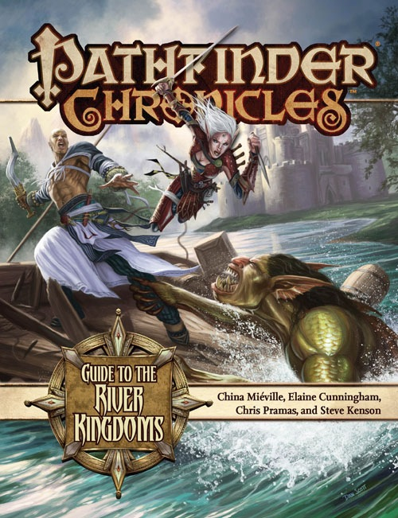  Guide to the River Kingdoms  Learn about the areas surrounding the Echo Wood | 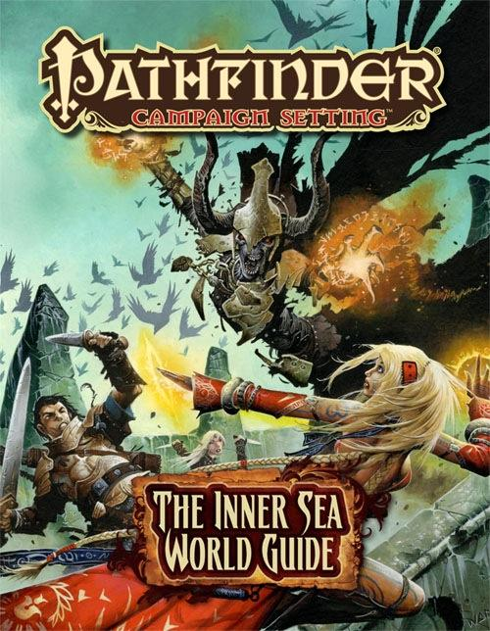  The Inner Sea World Guide  Explore the world beyond the River Kingdoms.
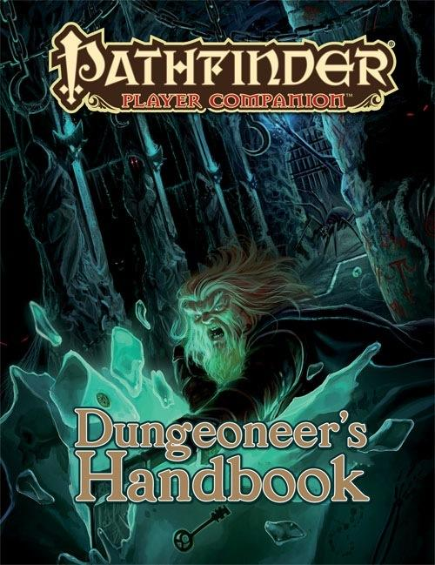  Dungeoneer’s Handbook  Prepare yourself for a delve into the deep. | 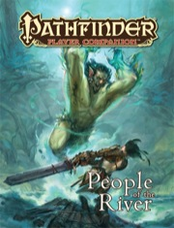  People of the River  Become one with the waterways.

OPEN GAME LICENSE Version 1.0a
The following text is the property of Wizards of the Coast, Inc. and is Copyright 2000 Wizards of the Coast, Inc (“Wizards”). All Rights Reserved.
1. Definitions: (a) “Contributors” means the copyright and/or trademark owners who have contributed Open Game Content; (b) “Derivative Material” means copyrighted material including derivative works and translations (including into other computer languages), potation, modification, correction, addition, extension, upgrade, improvement, compilation, abridgment or other form in which an existing work may be recast, transformed or adapted; (c) “Distribute” means to reproduce, license, rent, lease, sell, broadcast, publicly display, transmit or otherwise distribute; (d) “Open Game Content” means the game mechanic and includes the methods, procedures, processes and routines to the extent such content does not embody the Product Identity and is an enhancement over the prior art and any additional content clearly identified as Open Game Content by the Contributor, and means any work covered by this License, including translations and derivative works under copyright law, but specifically excludes Product Identity. (e) “Product Identity” means product and product line names, logos and identifying marks including trade dress; artifacts, creatures, characters, stories, storylines, plots, thematic elements, dialogue, incidents, language, artwork, symbols, designs, depictions, likenesses, formats, poses, concepts, themes and graphic, photographic and other visual or audio representations; names and descriptions of characters, spells, enchantments, personalities, teams, personas, likenesses and special abilities; places, locations, environments, creatures, equipment, magical or supernatural abilities or effects, logos, symbols, or graphic designs; and any other trademark or registered trademark clearly identified as Product identity by the owner of the Product Identity, and which specifically excludes the Open Game Content; (f ) “Trademark” means the logos, names, mark, sign, motto, designs that are used by a Contributor to identify itself or its products or the associated products contributed to the Open Game License by the Contributor (g) “Use”, “Used” or “Using” means to use, Distribute, copy, edit, format, modify, translate and otherwise create Derivative Material of Open Game Content. (h) “You” or “Your” means the licensee in terms of this agreement.
2. The License: This License applies to any Open Game Content that contains a notice indicating that the Open Game Content may only be Used under and in terms of this License. You must affix such a notice to any Open Game Content that you Use. No terms may be added to or subtracted from this License except as described by the License itself. No other terms or conditions may be applied to any Open Game Content distributed using this License.
3. Offer and Acceptance: By Using the Open Game Content You indicate Your acceptance of the terms of this License.
4. Grant and Consideration: In consideration for agreeing to use this License, the Contributors grant You a perpetual, worldwide, royalty-free, non-exclusive license with the exact terms of this License to Use, the Open Game Content.
5. Representation of Authority to Contribute: If You are contributing original material as Open Game Content, You represent that Your Contributions are Your original creation and/or You have sufficient rights to grant the rights conveyed by this License.
6. Notice of License Copyright: You must update the COPYRIGHT NOTICE portion of this License to include the exact text of the COPYRIGHT NOTICE of any Open Game Content You are copying, modifying or distributing, and You must add the title, the copyright date, and the copyright holder’s name to the COPYRIGHT NOTICE of any original Open Game Content you Distribute.
7. Use of Product Identity: You agree not to Use any Product Identity, including as an indication as to compatibility, except as expressly licensed in another, independent Agreement with the owner of each element of that Product Identity. You agree not to indicate compatibility or co-adaptability with any Trademark or Registered Trademark in conjunction with a work containing Open Game Content except as expressly licensed in another, independent Agreement with the owner of such Trademark or Registered Trademark. The use of any Product Identity in Open Game Content does not constitute a challenge to the ownership of that Product Identity. The owner of any Product Identity used in Open Game Content shall retain all rights, title and interest in and to that Product Identity.
8. Identification: If you distribute Open Game Content You must clearly indicate which portions of the work that you are distributing are Open Game Content.
9. Updating the License: Wizards or its designated Agents may publish updated versions of this License. You may use any authorized version of this License to copy, modify and distribute any Open Game Content originally distributed under any version of this License.
10. Copy of this License: You MUST include a copy of this License with every copy of the Open Game Content You distribute.
11. Use of Contributor Credits: You may not market or advertise the Open Game Content using the name of any Contributor unless You have written permission from the Contributor to do so.
12. Inability to Comply: If it is impossible for You to comply with any of the terms of this License with respect to some or all of the Open Game Content due to statute, judicial order, or governmental regulation then You may not Use any Open Game Material so affected.
13. Termination: This License will terminate automatically if You fail to comply with all terms herein and fail to cure such breach within 30 days of becoming aware of the breach. All sublicenses shall survive the termination of this License.
14. Reformation: If any provision of this License is held to be unenforceable, such provision shall be reformed only to the extent necessary to make it enforceable.
15. COPYRIGHT NOTICE
Open Game License v 1.0a © 2000, Wizards of the Coast, Inc.
System Reference Document © 2000, Wizards of the Coast, Inc.; Authors Jonathan Tweet, Monte Cook, Skip Williams, based on material by E. Gary Gygax and Dave Arneson.
Pathfinder Module: The Emerald Spire Superdungeon © 2014, Paizo Publishing, LLC. Authors: Keith Baker, Richard Baker, Wolfgang Baur, Jason Bulmahn, Ed Greenwood, Tim Hitchcock, James Jacobs, Nicolas Logue, Frank Mentzer, Erik Mona, Chris Pramas, Sean K Reynolds, F. Wesley Schneider, Michael A. Stackpole, Lisa Stevens, and James L. Sutter.
Pathfinder Online: Thornkeep © 2012, Paizo Publishing, LLC. Authors: Richard Baker, Jason Bulmahn, Ryan S. Dancey, Ed Greenwood, Lee Hammock, James Jacobs, Mark Kalmes, Erik Mona, Lisa Stevens, and Michael Wallin.
Emerald Spire Player's Guide © 2014, 5 Minute Workday Publishing. Authors: David Gibson.

