Open desert No effects.
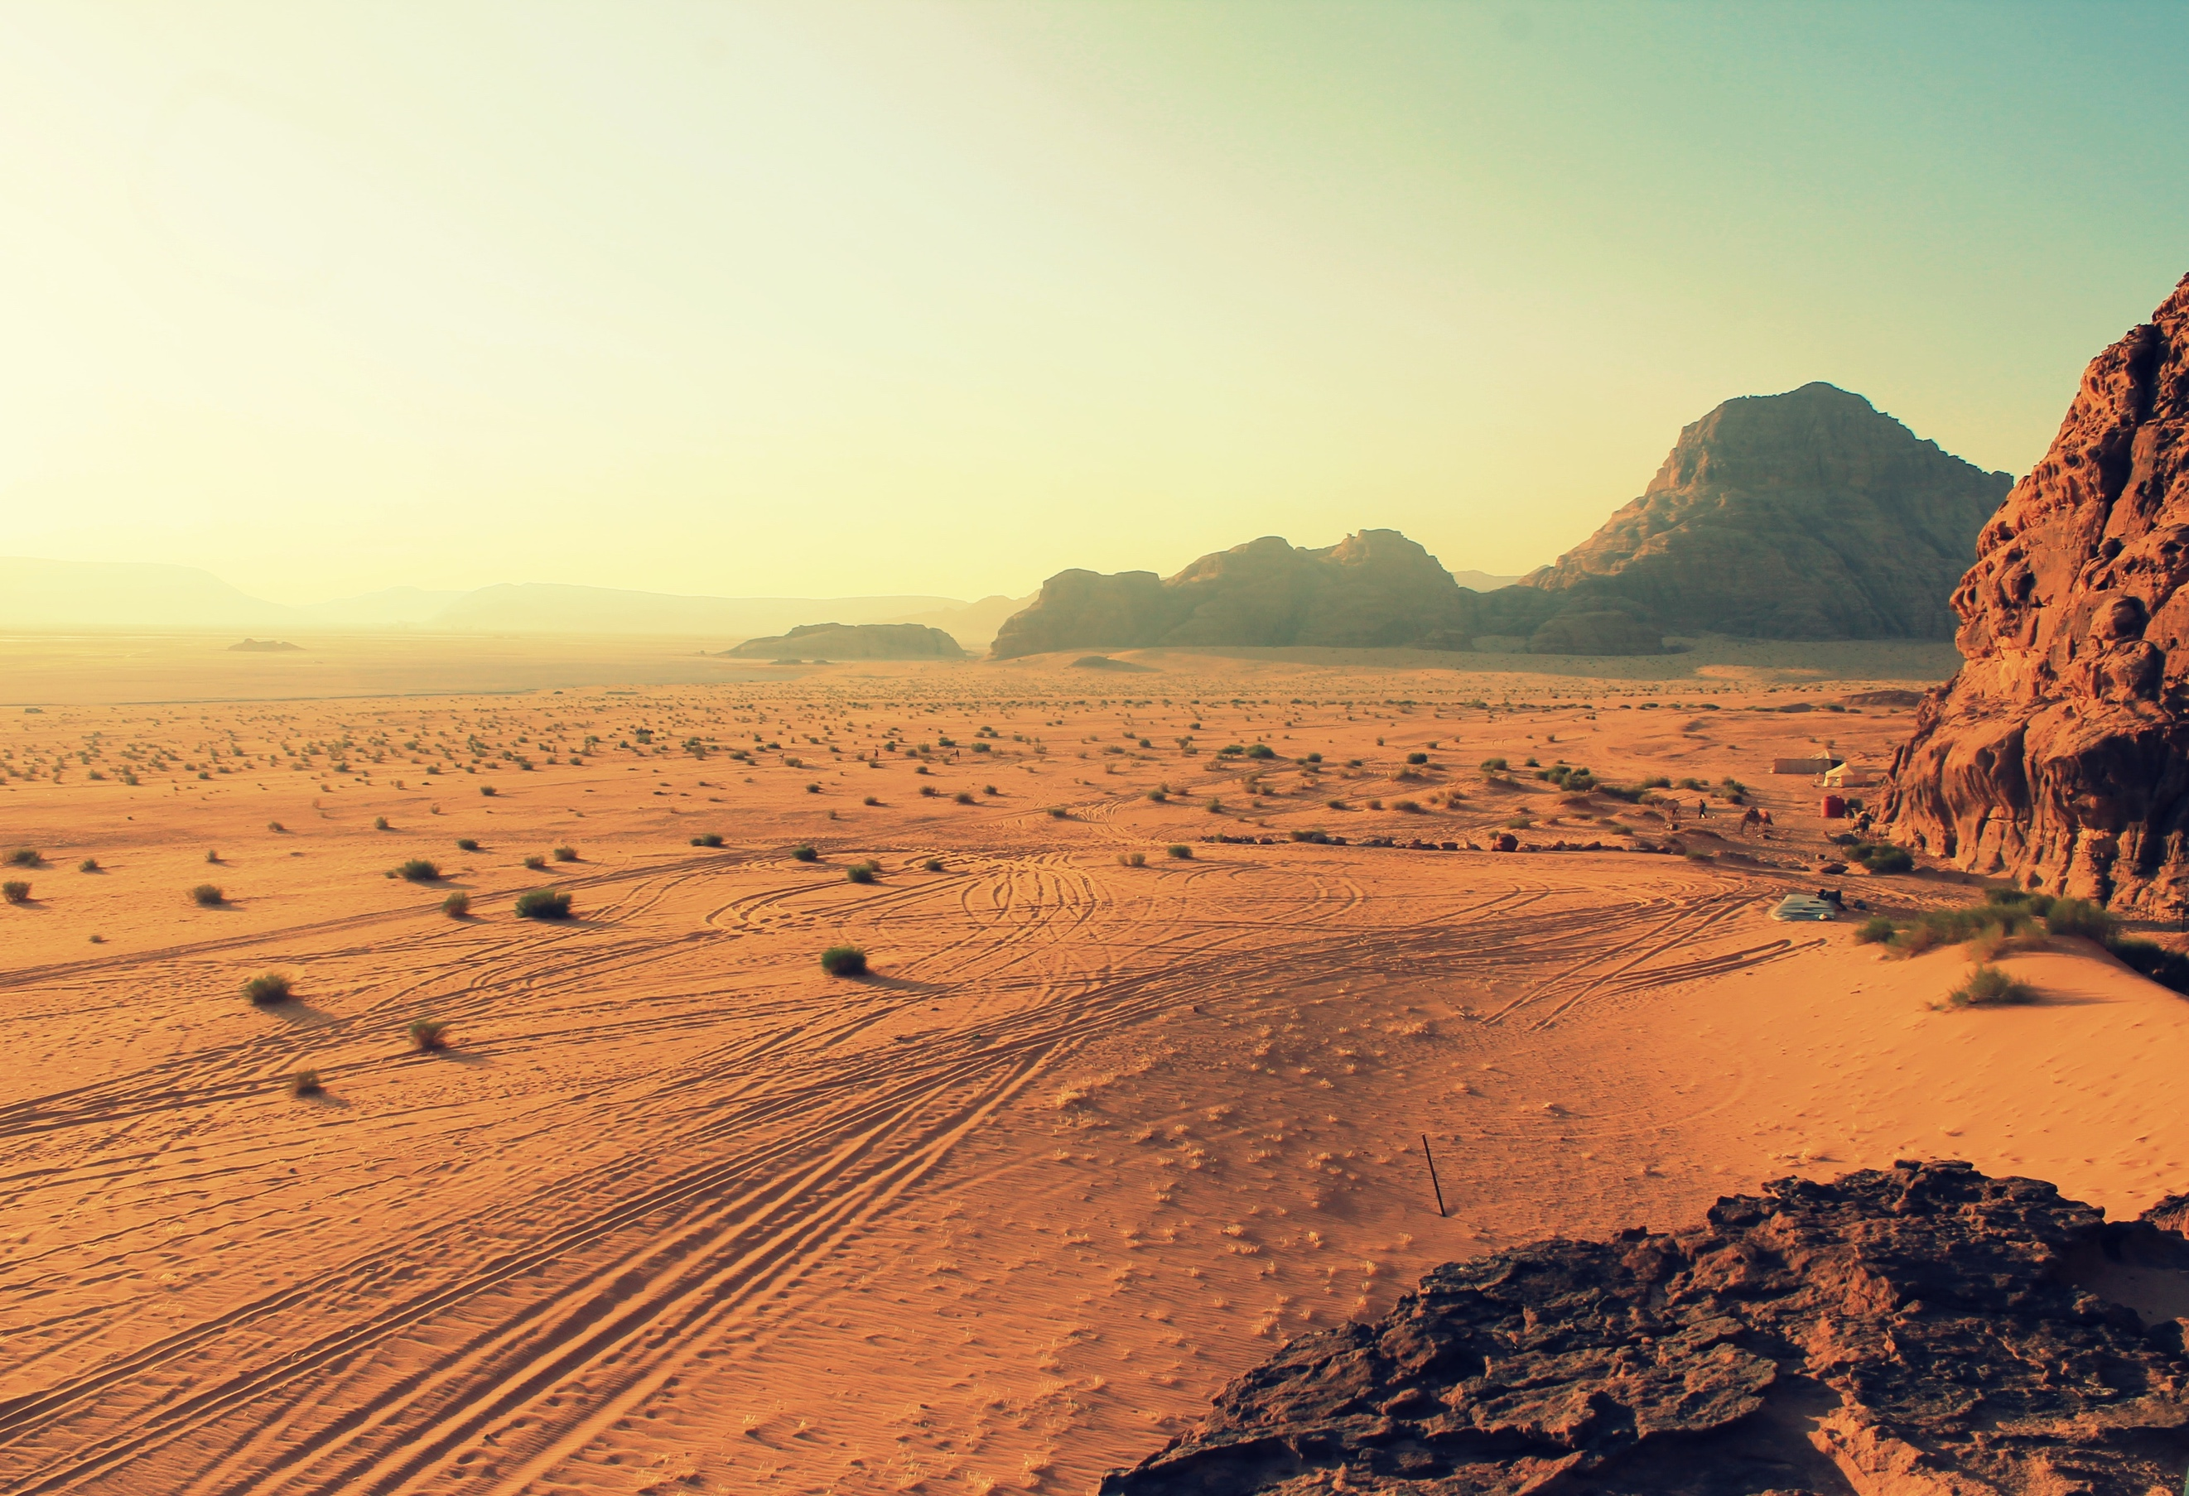

Dunes Altered Movement: Deep sand (–2 to Piloting)
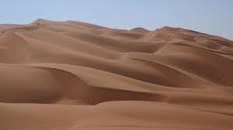
Stone monoliths
Altered Attacks: Rock spires (cover);
New Trick: Topple rocks (Piloting or ranged attack roll
New Active Hazard: –2 to Piloting and must evade or vehicle takes 5d8 damage). 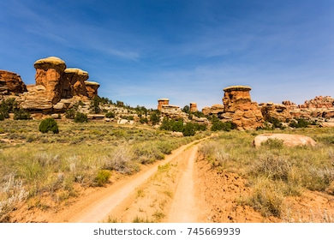

Giant Anthill Active Hazard: Defensive ants (must evade or vehicle takes 5d8 damage); New Trick: Bolting ants (–4 to Piloting)
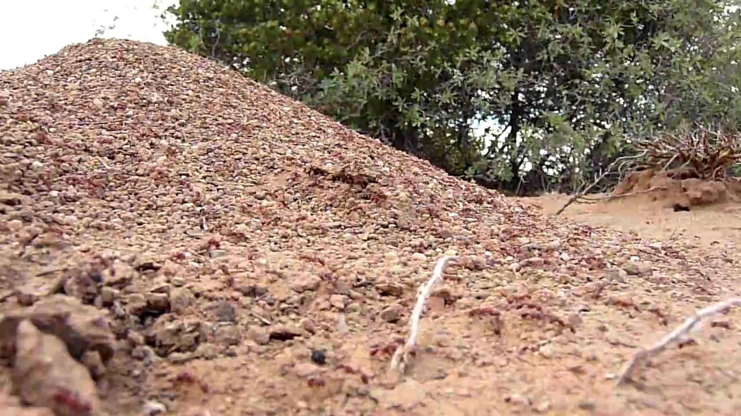

Ramps Split Routes: Jump across a ravine (Piloting DC 20 + item level or vehicle takes 5d8 damage; hardness applies), go around (–4 to Piloting checks to keep pace or speed up)
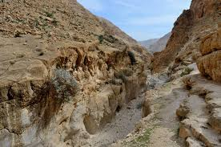

Salt flats Altered Movement: Good grip (+4 to Piloting).
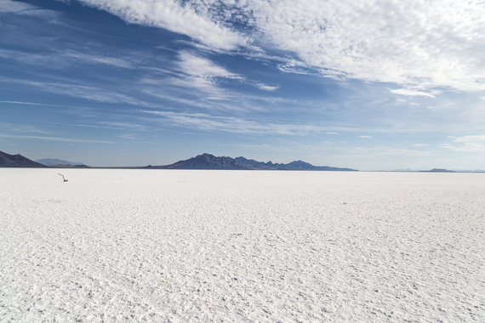

Sandstorm Altered Attacks: Sandstorm (concealment).
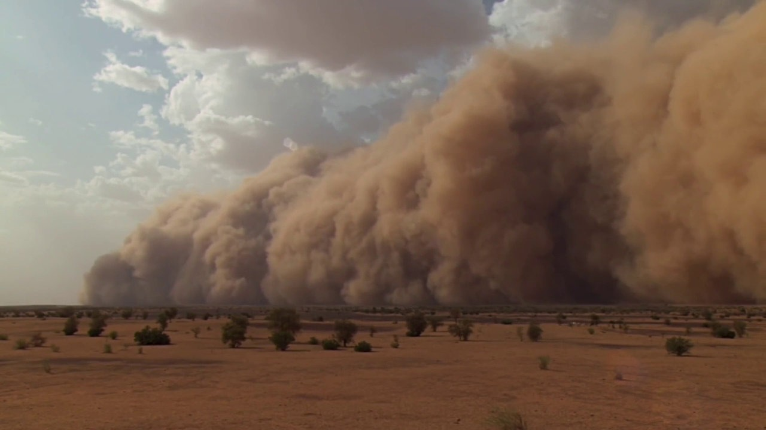

Canyon Altered Movement: Narrow canyon (–2 to Piloting); Active Hazard: Falling rocks (must evade or vehicle takes 5d8 damage).

