Name |  | Position | Physicality | Character | Notes
Veane | 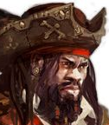 | Captain | Human (m) | Practical and usually businesslike.
Marzack Mallik | 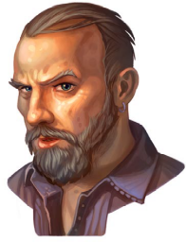 | First Mate | Human (m) | Brusque, doesn’t talk much about himself
Ulamon | 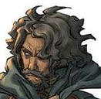 | Navigator | Human (m) | Usually keeps to himself. Whines quite a bit. Has control over weather.
Shira Acidaxe | 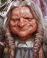 | Cook | Dwarf (f) | Seems bitter. You often hear her muttering rudely under her breath.
Killik | 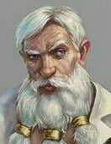 | Medic | Human (m) | Not unkind, but definitely uncaring. Only seems interested in money.
Anera | 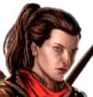 | Deckhand /protection | Human (f) | Speaks or interacts little. Has a pet bird called Keeneye.
Azuretta |  | Morale | Half-elf (f) | Friendly and sometimes maybe a bit too forward.
Velagon Dorhay | 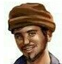 | ‘Trader’ | Human (m) | Transporting rare creatures. Is usually in the cargohold tending to them.
Snig Lacorse | 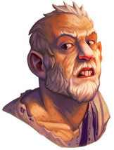 | Stowaway | Human / were-rat (m) | Tries to stay hidden, but the crew all know he’s there. Since he keeps the rat population low, they don’t mind.
Sephiriel | 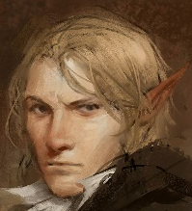 | Diplomat | Elf (m) | A kind and learned man, but definitely a politician.
Thanzuril | 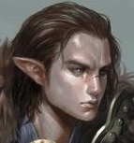 | Sepheriel’s bodyguard | Elf (m) | Open, friendly, and usually happy to talk as long as it doesn’t interfere with his duties.

